A Limited Team Adventure: Mom Has the Kids... Again
Anthony Alongi
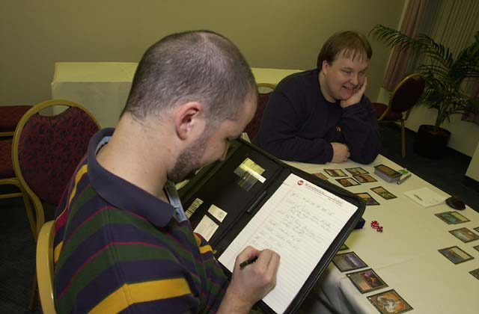
Anthony Alongi, International Man of Mystery
A few months ago, when I almost unintentionally came within a couple matches of qualifying for Pro Tour-LA, Dale Taylor (from Team Monster Rod) pulled me aside and said in his typically blunt style, "Anthony, if you want to make the Pro Tour, you are going to make it. The only thing between you and the Tour is practice. That's it."
What a nice thing for him to say! Take a bow, Dale, and prepare to have your reputation as a scout for young talent put on the line.
I have done a great deal of writing on Magic for the past two years. Most of it has been about casual games. Fortunately, most pros I've met don't hold that against me. For those increasingly frequent occasions when I've written for the Sideboard at professional events, I have found highly competitive Magic to be enjoyable, and the pros themselves to be accessible and open about their game and strategy.
I guess what I'm trying to say is that competitive players are such a lovely group of folks, I'd love to join you.
My friend Todd Petit, who has sampled the Pro Tour, and I decided shortly after that qualifier that we ought to get together more often and talk strategy. Not that we didn't already: we're in Dreamers, a local game store, periodically, and that gives us the opportunity to play and talk with some of the best Magic minds in the state. Among those minds are the members of Team Monster Rod (Cory Ferguson, Dale Taylor, and Noah Weil), who placed eighth at last year's PT-NY. Todd and I figured that with a little bit of extra time and effort, we might improve ourselves to the point where we could enjoy an invite to next year's New York.
Team Limited, of course, requires three people. If Todd and I were college students with lots of time on our hands, we would no doubt reach out to the nearest three unattached Pro players and ask them if any of them wanted to be on our team. We'd practice over the internet eight hours a day, spend spring break together, and stay up until 4 am discussing whether Marx would have been a creature type Rebel or Beast.
But we can't do that. We have different realities to face. Their names are Connor, Helen, Christina, and Liam, and they all need help reaching the ice pops in the freezer. Our wives are supportive but human; they aren't perpetual day care vessels. And I'm not crying about our situation: our kids' needs are so much more important than competitive Magic that it seems to me ridiculous having both in the same sentence.
We needed a third player who would be in a similar situation, so that we would all understand the basic pressures of family commitment. It would help if that player were someone we knew and felt comfortable with; and it would be just spiffy if that player had good, raw talent.
Enter Curt Jorenby, married with two kids, who has been playing the game casually for the last couple of years. Having him on board gives us another "ice-style" player who doesn't get flustered easily and understands the psychological aspects of the game.
Besides, Zvi wasn't available.
We had our team, and our name was easy to generate: Team "Mom Has the Kids...Again." Short, clear... and horrifically accurate. Our wives don't really find the title that amusing; but as we don't expect them to serve as our practice team, we're willing to live with the flak.
Every week or two or three, as our efforts progress, we plan on sharing our experiences and perspectives with the Magic community. We'll be talking about things that folks new to team formats might not know yet - e.g., what practice methods work best - and a few things even seasoned pros might still find helpful - e.g., how to keep a team dynamic healthy and productive.
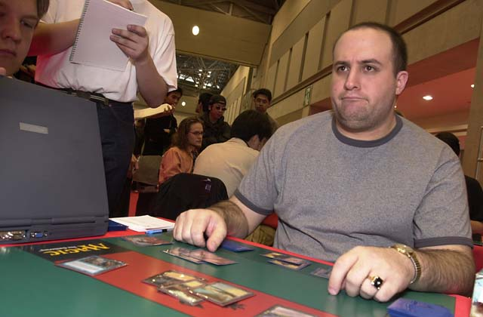
While I will be prattling on the most in these offerings, I expect both Curt and Todd will have insights that they will add to my own. I will also be in contact with many personalities throughout the Magic community. Some of these will be seasoned pros, some will be aspirants like ourselves. Most importantly, all will gladly trade team Rochester advice for an internship opportunity and/or a pack of Keebler Fudge Shoppe cookies.
With hard work and luck, we'll be able to conclude the story a few months from now with a tournament report from New York. But whether we do or not, we hope you'll find the journey compelling.
Coming Next: Group goals and sealed practice decks.

